JEM FOUNDATION SCHOOLS
ANNUAL EXAMINATION (2019 – ’20)
CLASS : VII M.M : 80
SUBJECT: MATHEMATICS TIME: 3 H
Instruction: All questions are compulsory.
SECTION – A 1 12 = 12 marks
.Choose the correct options :
1. If 3 + 2x = 1 – x, then x = ?
a) b) 0 c) 1 d)
2. A man buy a book for ₹80 and sells it for ₹100. His gain% is
a) 20% b) 25% c) 120% d) 125%
3. 2.34 100 = ?
a) 23.4 b) 234 c) 0.0234 d) 0.234
4. ⁻¹ = ?
a) b) c) d) 0
5. Perimeter of a rectangle is
a) side x side b) 4 x side c) 2 x (l + b) d) 2 x (l + b)h
6. The simple interest at x% per annum for x years will be ₹x on a sum of
a) ₹x b) ₹100x c) ₹ d) ₹ ( )
Do as directed:
7. The reciprocal of 6 is ________.
8. On subtracting 4 from -4, we get _______
9. All squares are congruent. (True/False).
10. In the ratio a : b, the first term is b and the second term is a. (True/ False).
11. Subtract (x – y) from (4y – 5x).
12. Multiply (2a²b³) x (-3a³b)
. SECTION – B 2 10 = 20 marks
13. The sum of two integers is 65. If one of them is -31, find the other.

14. Take out 5.746 from 9.1.
15. Find the product : (5y – 1)(3y – 8)
16. Find the mean of first five prime numbers.
17..A number when multiplied by 4, exceeds itself by 45. Find the number.
18. Find the product s(s² – st) and find its value for s = 2 and t = 3.
19. Express in simplest form: 8 months : 1 year.
20.. A dice is tossed 80 times and the number 3 is obtained 14 times. Now a dice is tossed at random . Find the probability of getting the number 3.
21. Solve : - = 1
22. If 2 : 9 :: x : 27, find the value of x.

Page 1 of 2

SECTION – C 3 8 = 24 marks
23. If 9 x 3^{n} = 3⁶ , find the value of n.

24. At what rate per cent per annum will ₹4500 amount to ₹5715 in 3 years.
25. On selling a sofa – set for ₹21600, a dealer gains 8% . For how much did he purchase it ?.

26. Find the cost of carpeting a room 13 m by 9 m with a carpet of width 75 cm at the rate of ₹105 per metre.

27. Find the product of (4x – 3)( 2x + 5) 50º y l
28. In the given figure, i//m. If s and t be the transversals such that s is not parallel
to t, find the values of x and y. x 65º
s t
29. In the given figure, PA ⊥ AB, QB ⊥ AB and PA = QB. Prove that OMP OBQ. Is OA = OB ?
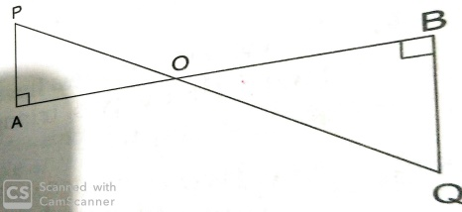
30. Write the data given below in ascending order and prepare the frequency table .
7, 8, 7, 10, 6, 8, 9, 7, 10, 5, 7, 6, 8, 5, 6, 7, 8, 9, 7, 6, 7, 8.

SECTION – D 4 6 = 24 marks
31. A man sold two radios at ₹4800 each. On one he gains 20% and on the other he loses 20%.
Find the gain or loss per cent in the whole transaction.

32. Construct a ABC in which AB = AC = 4.8 cm and BC = 5.3 cm. Measure B and C. Draw
AD ⊥ BC.

33. A dice is thrown 200 times and the outcomes are noted as shown below:
Outcome | 1 | 2 | 3 | 4 | 5 | 6
Frequency | 21 | 30 | 42 | 38 | 29 | 4
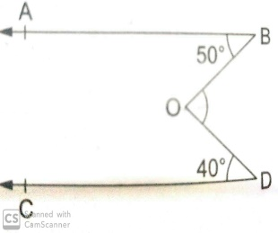
34. In the adjoining figure, it is given that AB//CD, ABO = 50º and CDO = 40º.
Find the measure of BOD.

35. The heights (in cm) of 90 plants in a garden are given below:
Find the mean height.

Height (in cm) | 58 | 60 | 62 | 64 | 66 | 74
Number of plants | 20 | 25 | 15 | 8 | 12 | 10

36. Find the simple interest and amount when:
Principal = ₹ 2650, rate = 8% and time = 2½ %.
Page 2 of 2

